Scottish Chess Tour
A Chess Scotland Chessbase.com Scottish Grand Prix qualifying event

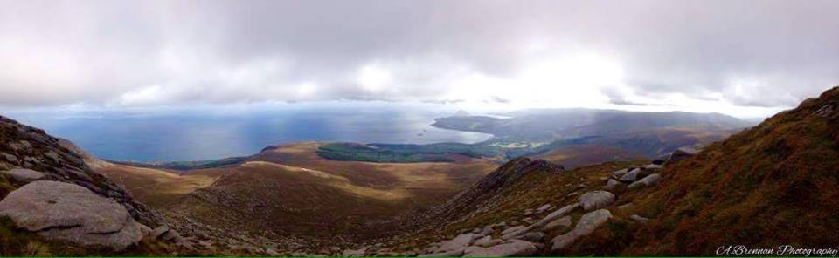

Arran FIDE Rapidplay 2018
Saturday 15th September
One day allegro from 11:15am to 4:30pm
Venue – Brodick Public Hall, Brodick, Isle of Arran, KA27 8DL.

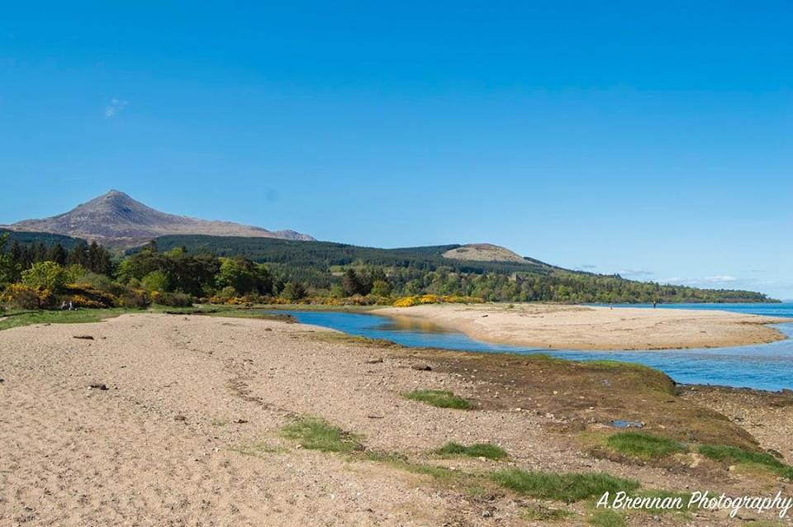

Grading

This year we will be using Chess Scotland grades in following sequence

1. CS live Allegro grade if player has one
2. CS live Normal grade if player doesn’t have an Allegro grade
3. CS Normal grade at start of the season
4. If none of the above then an Estimated grade may be used

All results from this event will be submitted to Chess Scotland for Allegro grading.

Events

1. Open. Open to all entrants
2. Major. Open to entrants with a grade of 1750 or less
3. Minor. Open to entrants with a grade of 1450 or less – see above

Total entry limited to 50 players across the three sections. If the entry limit is reached, further applicants will be notified & placed on a reserve list if they wish.

Round Timings as follows (Approximate).

Round 1 - 11.15am - 12.05pm
Round 2 - 12.15pm – 1.05pm
Lunch break - 1.05pm to 2.00pm
Round 3 - 2:00pm - 2:50pm
Round 4 - 3.00pm - 3.50pm
Round 5 - 4.00pm - 4.50pm

This event will be held as a five round Allegro event played according to the Chess Scotland Rules Book including the 2018 FIDE Laws of Chess Appendix on Rapidplay games.

Each player has 25 minutes for their moves in each round. The tournament will be run as a Swiss event - this means that everyone plays five games (it is NOT a knockout). Rule A4 of Appendix A. Rapidplay rules will apply to all games

ENTRY FEES

All events

Adults £14 Juniors (under 16 on the day) £9

CONDITIONS

The organisers reserve the right to:
- Increase or decrease prize money.
- Transfer entrants between events.
- Split or merge events depending on numbers.
- Withhold prizes from ungraded players if they play in events below their known strength.
- The organisers reserve the right to refuse entry without assigning a reason.
- Take any other measures deemed necessary to ensure the smooth running of the congress.

PRIZES

1. Open: First £100, Second £50, Third £30

2. Major: First £75, Second £45, Third £30

3. Minor: First £75, Second £45, Third £30

All prizes quoted above are dependent on a sufficient number of entrants and may be adjusted at the discretion of the organisers. Other prizes may be awarded at the discretion of the organisers.

Where places are tied for the prizes will be shared.

There will be no official prize giving immediately after the congress. All prizes will be mailed by cheque or paid by bank transfer in the week following the congress. It is therefore important that all entrants provide a home address or a contact e-mail to ensure that all prize winners receive their prize. This saves players who finish early in round 5 from waiting around to receive prizes and allows the organising team (and players) to clear down the event and catch the ferry back to the mainland.

GRAND PRIX EVENTS

Events will form part of the Chess Scotland Grand Prix and (where appropriate) the Walter Munn Junior Grand Prix organised by Chess Scotland

GETTING TO THE VENUE (and back again).

If you’re not lucky enough to live on the beautiful Isle of Arran or the Mull of Kintrye, we would suggest traveling to Ardrossan Harbour by train, then by ferry to Brodick. The venue is a short 15-minute stroll along Brodick seafront or a 3-minute hop on the bus. If you intend to catch the bus you should be prompt in disembarking from the ferry, as the buses leave quite promptly after the ferry arrives.

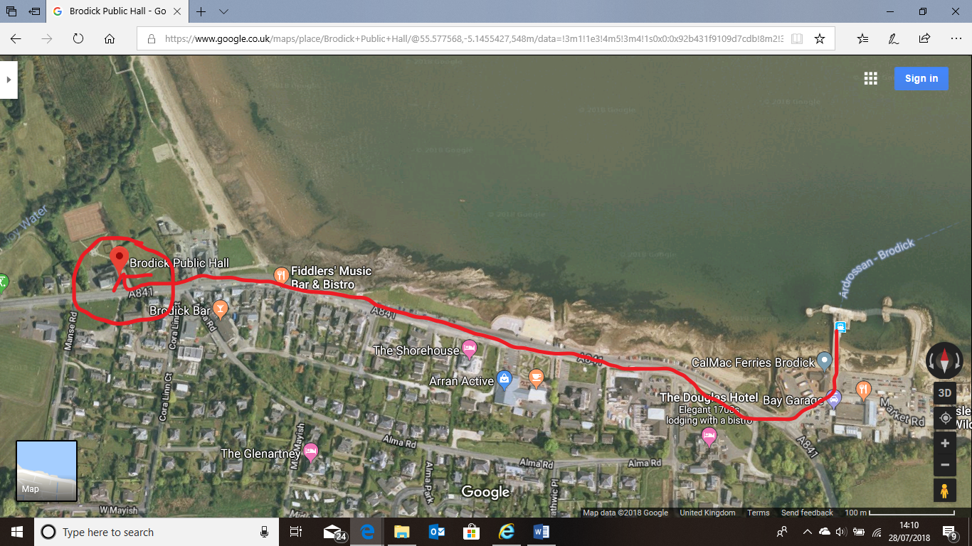

At the time of printing, a day return rail and sail ticket rom Glasgow Central to Brodick costs £16.40 return.

https://www.calmac.co.uk/railandsail/buy-your-tickets

The 08:34 train from Glasgow Central arrives at Ardrossan Harbour at 09:20, where you transfer to the 09:45 ferry to Brodick. The ferry arrives in Brodick at 10:40. There are two ferries back to the mainland, after the event finishes, the 18:00 and the 19:20.

https://www.calmac.co.uk/ardrossan-brodick-arran-ferry-summer-timetable

You can travel to the venue by car but car spaces on the ferry are limited and must be booked well in advance. It’s probably better to drive to Ardrossan Harbour and leave the car there in the car park (there is a charge per day), travelling to Arran as a foot passenger. A return foot passenger ticket is currently £7.80 for adults and £3.90 per child, return.

ENTRY FORM – Arran FIDE Rapidplay 2018

Name: ____________________________________
Address: ___________________________________ ___________________________________________
Email: ____________________________________
Club: _____________________________________
Grade: _____________ CS Pnum: ___________
DOB (if under 20): __________________________

Event: ___________________________________

Half Point Bye Required YES/NO Round __

Entry Fee: £ ___________
Donation (Thank You): £ ___________
Deduction Chess Scotland Member/Junior £____________
Total: £ ___________

I would like to receive information on future Scottish Chess Tour events by e-mail: YES/NO

Please return completed forms to:

David Congalton
12F Townhead
Irvine
Ayrshire
KA12 0BE

Tel - 01294 673140 between 6pm and 9pm weekdays and 10am to 9pm at weekends.
If no answer, please leave a message on answer machine and I’ll return your call. No calls after 9pm please.
E-Mail – admin@scotchesstour.co.uk

Entries by email MUST include a postal address.

Please make cheques payable to Ayrshire and Arran Chess Fellowship.

Scottish Chess Tour (SCT) – Privacy

Data will be passed on to both Chess Scotland and FIDE for grading purposes.

A list of entrants, individual matches and their results, overall congress results, and photographs of the event may be published on the Scottish Chess Tour website and by interested third chess related parties, such as Chess Scotland, as well as local press organisations.

Should a player not wish their photograph taken or have any issues with the use of their personal data, please inform the Tournament Director prior to the event so that we can respect your wishes.

